Warm-Up: Adults
It is important to get beginner golfers into a habit of warming up from their first session of coaching. This will help to reduce the risk of injuries and research has shown that it will benefit their performance.
Benefits of a Warm-Up for an Adult
It is important to be aware of some of the benefits of using a warm-up so that you can explain these to the golfers you are coaching.
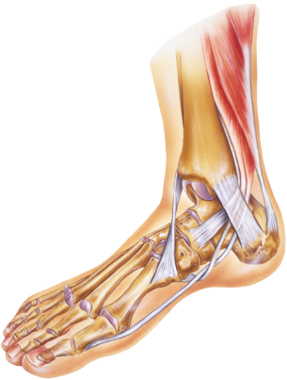
- Increase core and muscle temperatures.
- Reduces the risk of injury.
- Psychological benefits, e.g. improved focus and concentration.
- It can provide you (the coach) with some important information regarding the client’s physical characteristics and abilities. For example if the golfer completes the warm-up with ease it would suggest they are from an athletic background. Conversely if they struggle with some of the movements, it may highlight some physical limitations within their body. As a golf coach information like this is very important in order to help reach you reach your client’s objectives.
Warm-Up Framework
The framework below is similar to that of the junior warm-up. The difference is that these sessions have more structure and the client may want an understanding as to why a warm-up is important.
Raise: Increasing heart rate and body temperature.
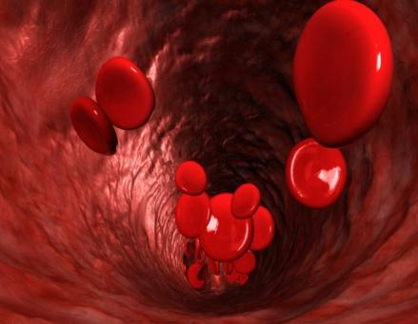
Raising heart rate – depending on the fitness levels of your golfer, it may be applicable to get the golfer to perform marching based exercises or jogging on the spot. A brisk walk around a safe area of the range for at least 5 minutes can often be enough to raise the heart rate and temperature of the muscles in some golfers. Others may feel they need more intense activities to get themselves warm. A good indicator as to whether the golfer is warm enough, is when they start to become a little out of breath.

Dynamic Stretches: Mobilising the body ready for performance.
Traditionally many golfers can be seen performing either no stretching or some basic static stretches prior to a round of golf or a practice session. Research has shown that static stretching can reduce the power output from the stretched muscles for up to 90 minutes post stretch and some even suggest that it could be as long as 24 hours before normal power output is exhibited!! These findings can obviously have a large impact upon performance. Therefore the current proposal is to use dynamic stretching prior to performance as this allows the golfer to achieve a mobilised, warmed up state before heading to the first tee. Static stretching should be used within a cool down where the emphasis is on trying to improve flexibility levels.

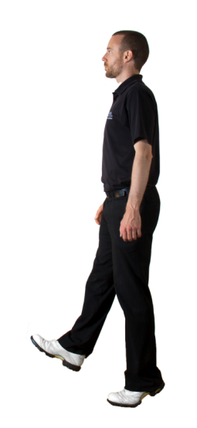
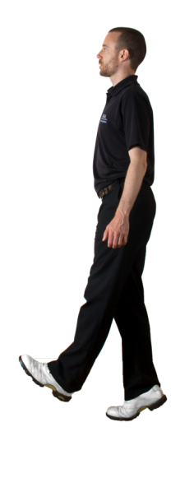

Calf Raises: Start with the foot flat on the ground and raise up onto the toe while the other foot is lifted out in front and the toes are pulled towards the shin. Repeat on the other side, alternate for 20 seconds.

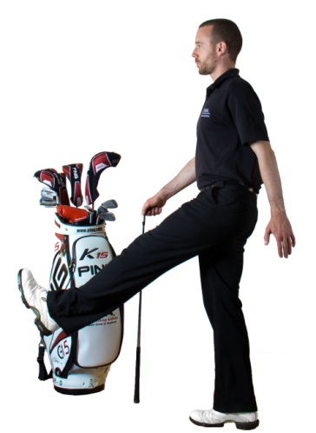
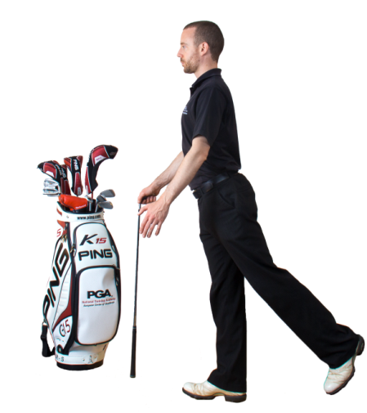

Leg Swings: For this exercise the golfer may want to hold onto the side of a bay, a golf club, or hold onto your shoulder if they are out on the course. Whilst standing upright and maintaining normal spine posture the golfer should swing their leg backwards and forwards for a set number of kicks. They should keep their swinging leg straight and feel the stretch in the back of their thigh (the hamstrings).
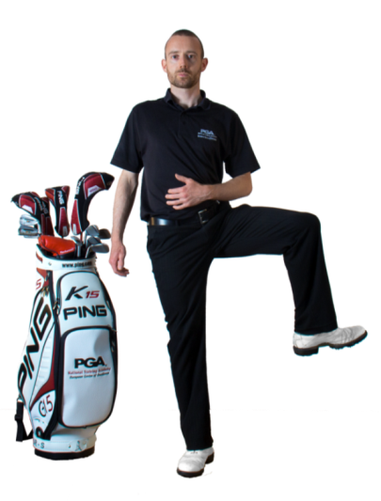
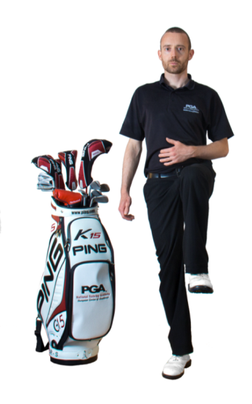

Open and Close the Gate: Starting from a standing position, to open the gate raise one knee into the air, circle the hip by taking the knee out to the side and back down to the ground. Repeat 5-10 times each side. To close the gate reverse the circle movement, take the knee out to the side first as you lift the foot off the ground, bring the knee around to the front and lower back to the ground. Again repeat 5-10 times each side.
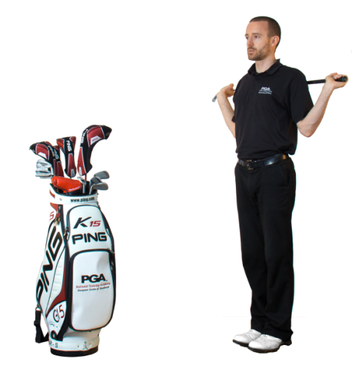
Sumo Squats: Place a club across the shoulders (or hold out in front of you to maintain balance), turn the feet parallel and slightly wider than shoulder width apart. Keeping the body upright, sit back into a squat position until the thighs just break parallel to the floor (or as far down as you can manage towards this point). Try to maintain spinal posture throughout. Do not hold the bottom position, immediately stand up and repeat 5-10 times. This exercise helps to dynamically stretch many areas of the body including the muscles of the legs, buttocks and upper body (especially the back).
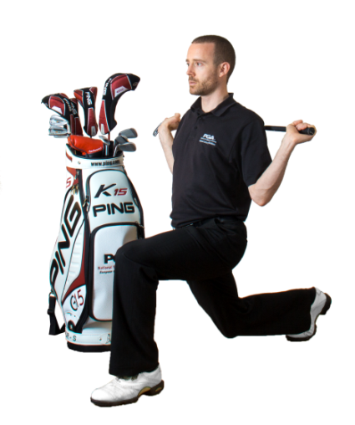

Lunges: Place a club behind the shoulders to help maintain posture throughout this dynamic stretch. Take a step forwards far enough so that the lead knee is above the heel of the foot and not over the toes. Bend the back knee as you lunge but be careful not to hit the ground. Press off the front foot to return to the starting position.

Torso Rotation Dissociation Drill: Place a club across the chest and adopt your golf address position. Keeping your hips as still as possible, rotate your upper body taking care to produce rotation rather than a “rocking the baby” action.
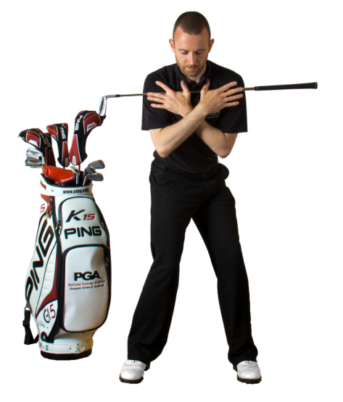
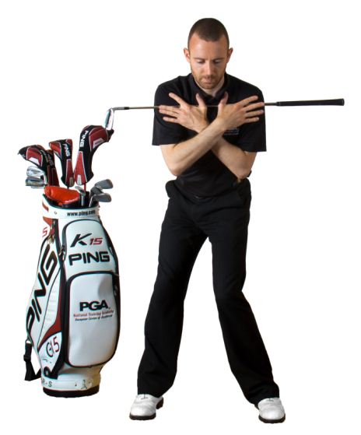

Pelvis Rotation Dissociation Drill: Place a club across the chest and adopt your golf address position. Keeping your shoulders as still as possible, rotate your pelvis taking care to produce rotation rather than a “swinging hips” action. Your knees may move during this exercise.
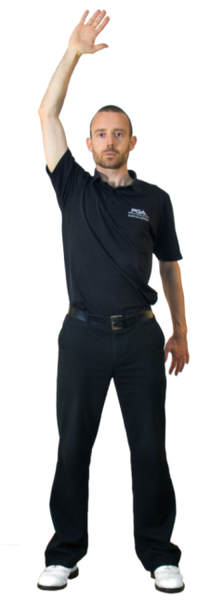
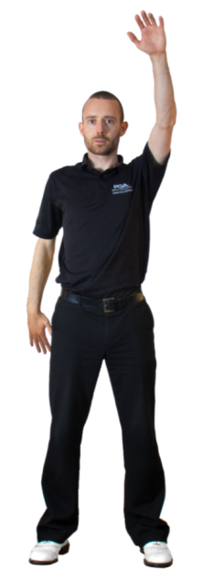

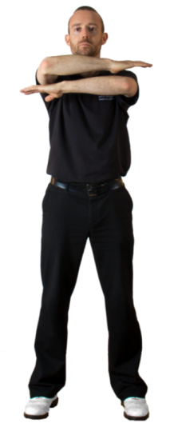
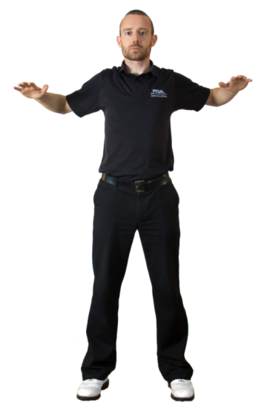
Vertical Arm Throws: Alternate the arms throwing them up and down feeling the stretch through the shoulder muscles. Keep the arm slightly bent at the elbow and palm facing forwards at the top. Keep them moving and do not hold any position. Repeat the throws for 20 seconds or 20 reps.

Horizontal Arm Throws: Alternate the arms throwing the elbows back and return to the start position with the other arm on top. You should feel the stretch through the chest and shoulder muscles. Make sure the head stays in a neutral position on top of the neck rather than poking the chin forwards as the arms move backwards. Keep the arms moving and do not hold any position. Repeat the throws for 20 seconds or 20 reps.

Golf Skills: Range and short game warm up prior to performance

The final phase of the adult warm up should be the same as with any aged golfer: warming up the skills that will be required out on the course. For example, this may mean hitting shots with specific clubs on the range, practicing bunker shots and getting used to the speed of the greens by spending time putting. Spend as much time as necessary to do this phase, but remember not to hit too many balls which will increase the chances of fatigue affecting performance. Also remember to stay warm, this may mean that, if the weather is particularly cold, the golfer has to repeat the pulse raisers and dynamic stretches after spending time putting to ensure the body is fully prepared to walk onto the first tee.

